**WEEK-1: Introduction to SE lab and Installation of Softwares**

1. Introduction to SE lab.
2. Installation of STAR UML, GITBASH for windows, GITHUB account creation.
3. Upload the Screenshots for STAR UML, GITBASH and GITHUB

**Star UML:**

**Installation of star UML:**

**Step:-1**

**Go to the browser and search for** <https://staruml.io/>

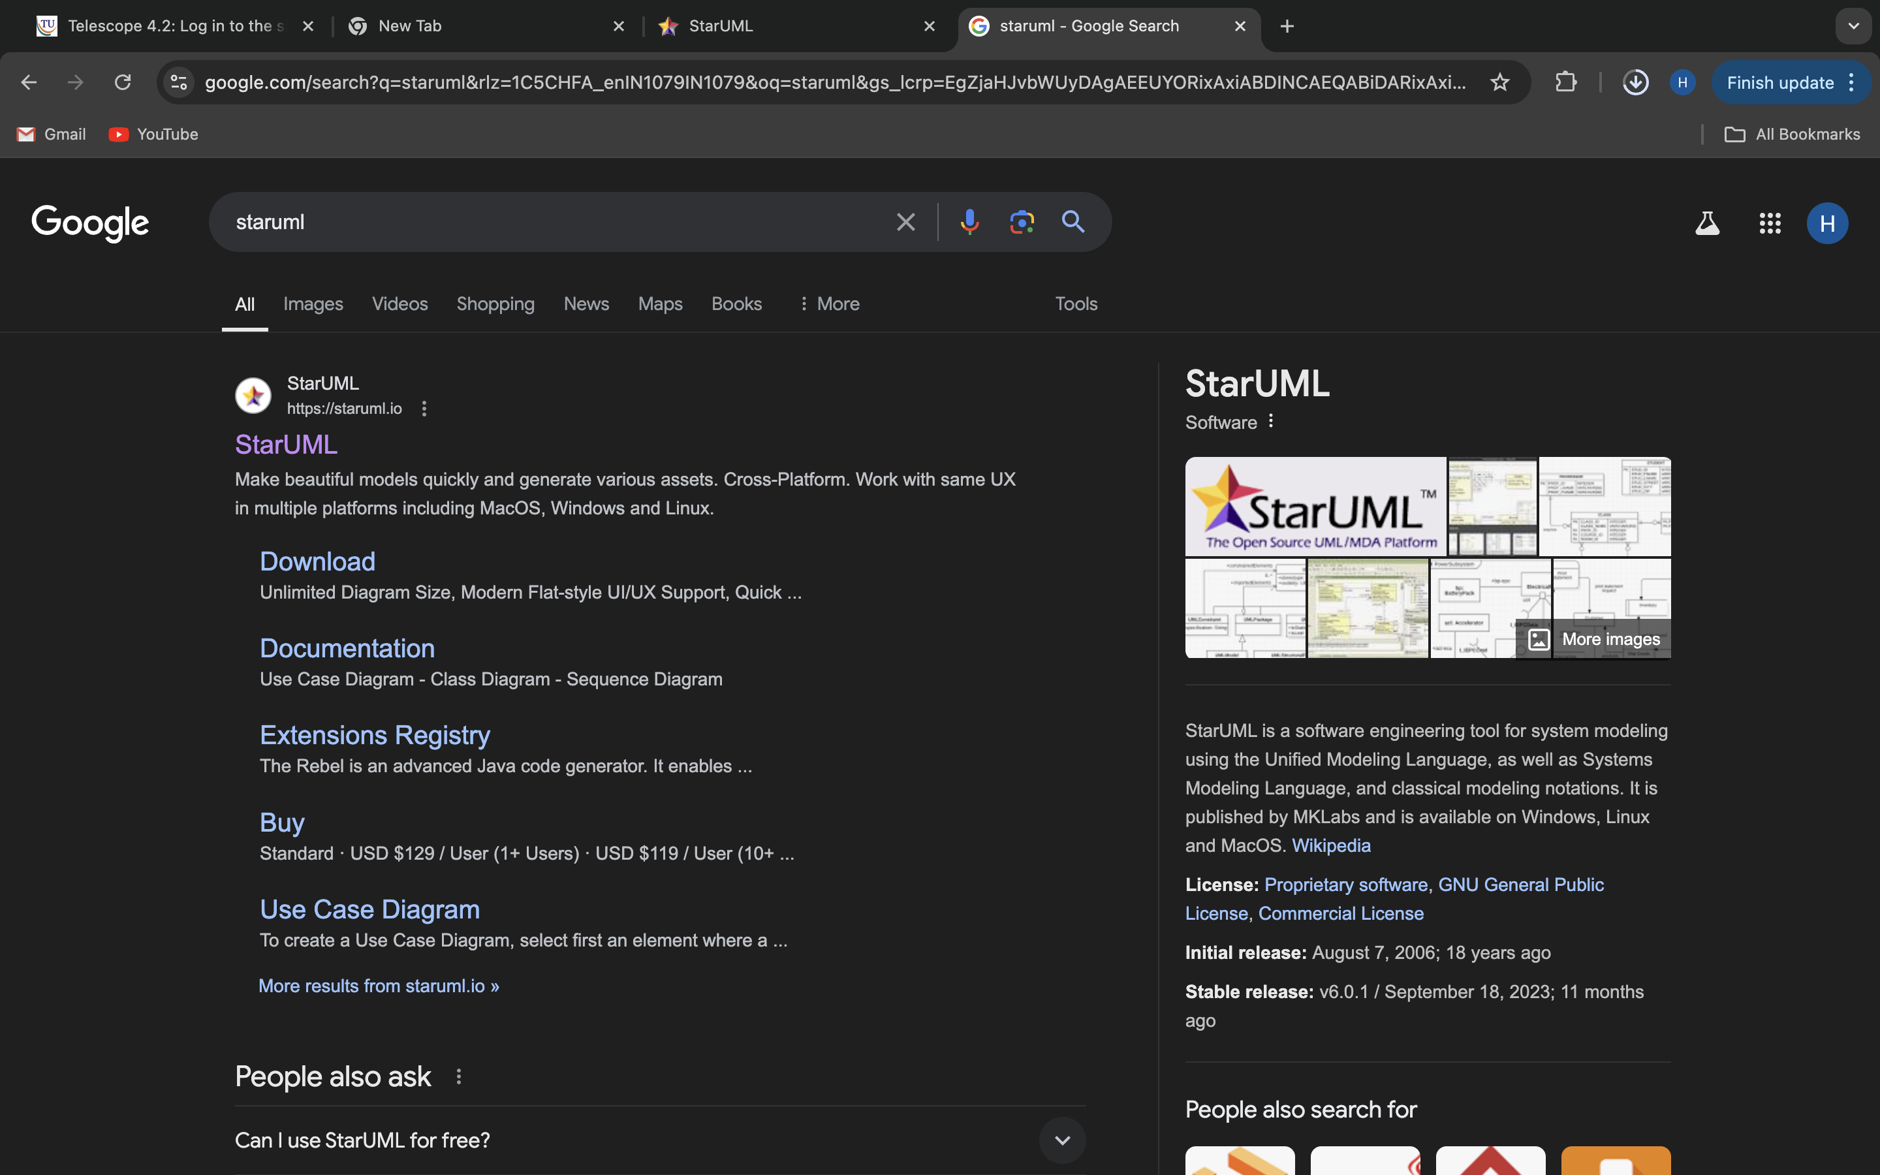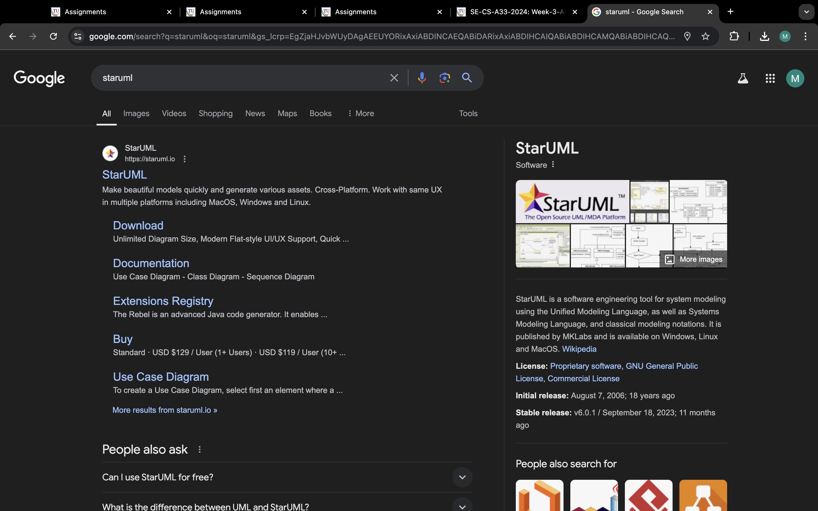

**Step:-2**

**Click download option for your respective operating system.**

**(Here I am doing on Mac OS)**

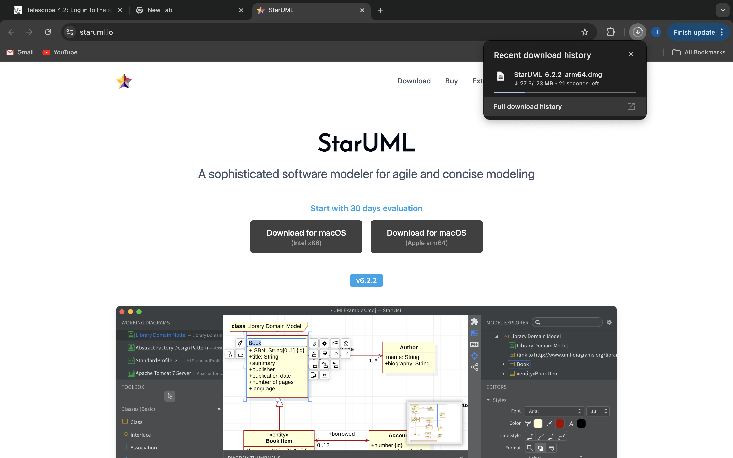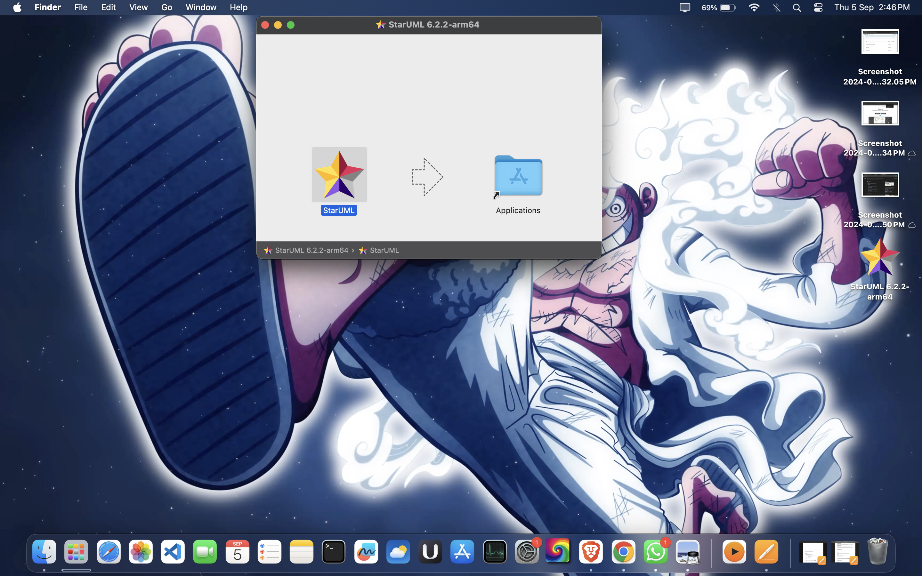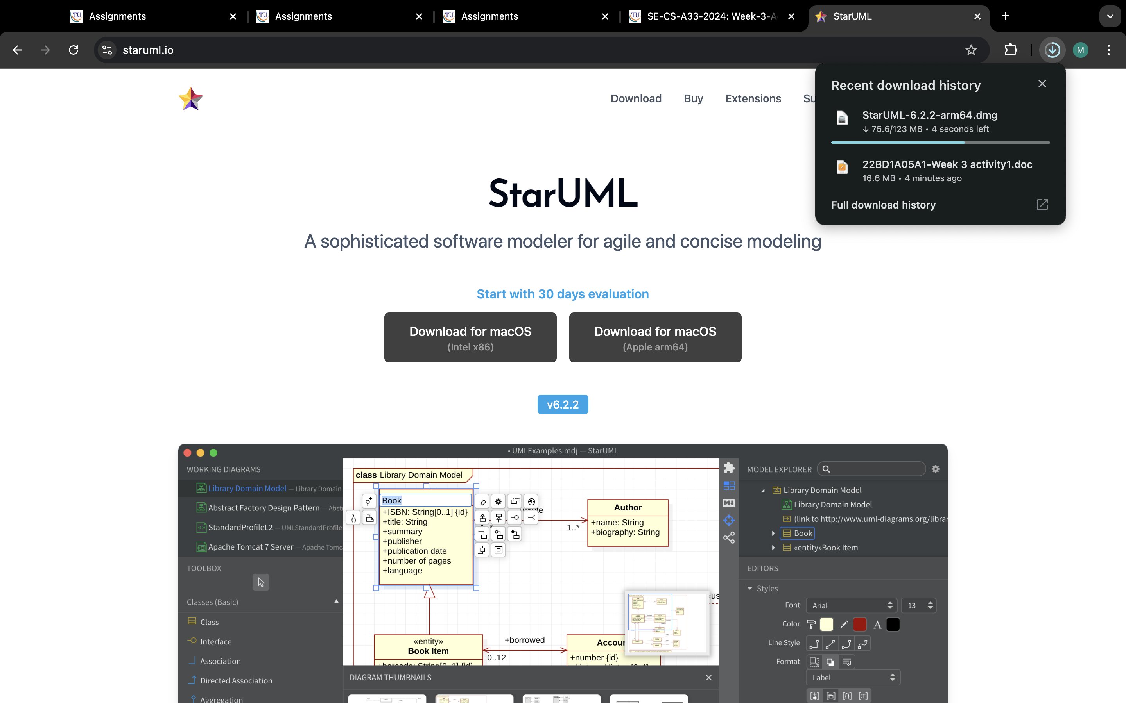

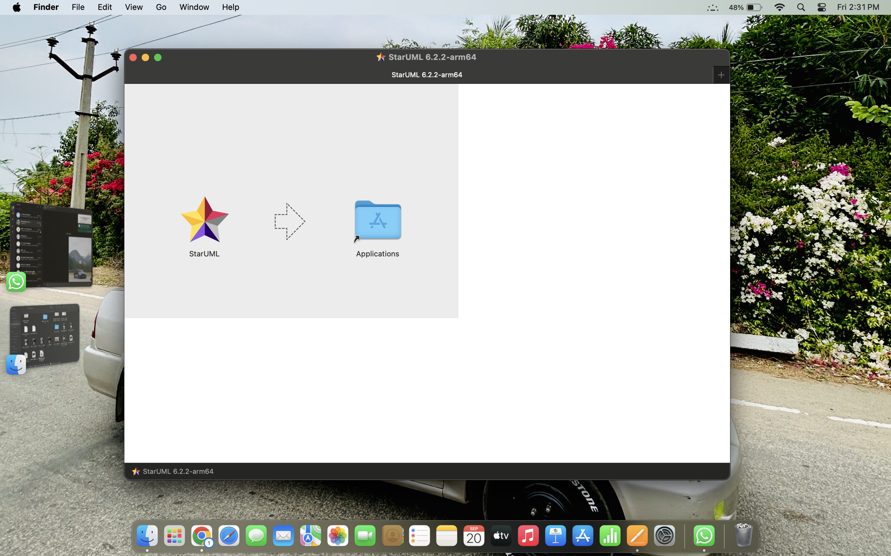

**Step:-3:**

**After downloading the file. Install the star UML software on your system.**

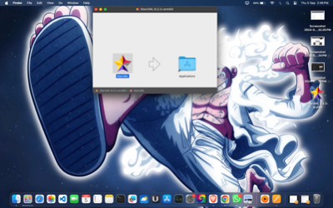

**Step:- 4:**

**After successful installation explore the star UML tool box**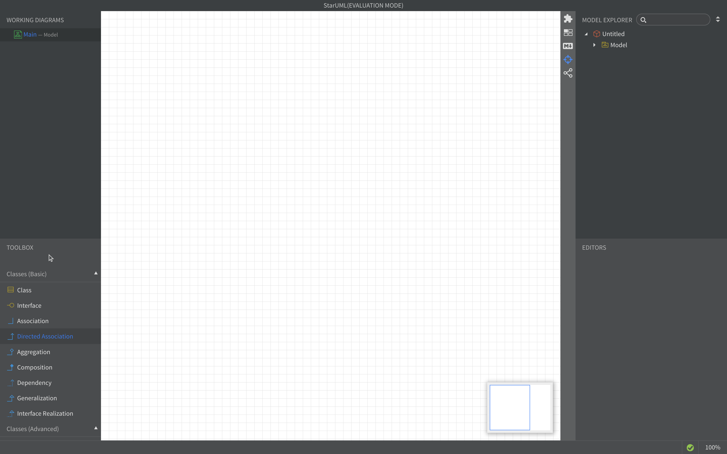

**Git-SCM:**

**Installation of Git-SCM:**

**Step:-1**

**Go to the browser and search for** [https://git-scm.com](https://git-scm.com/)

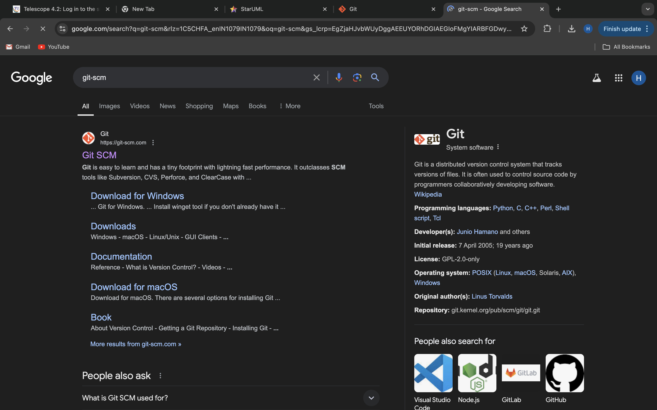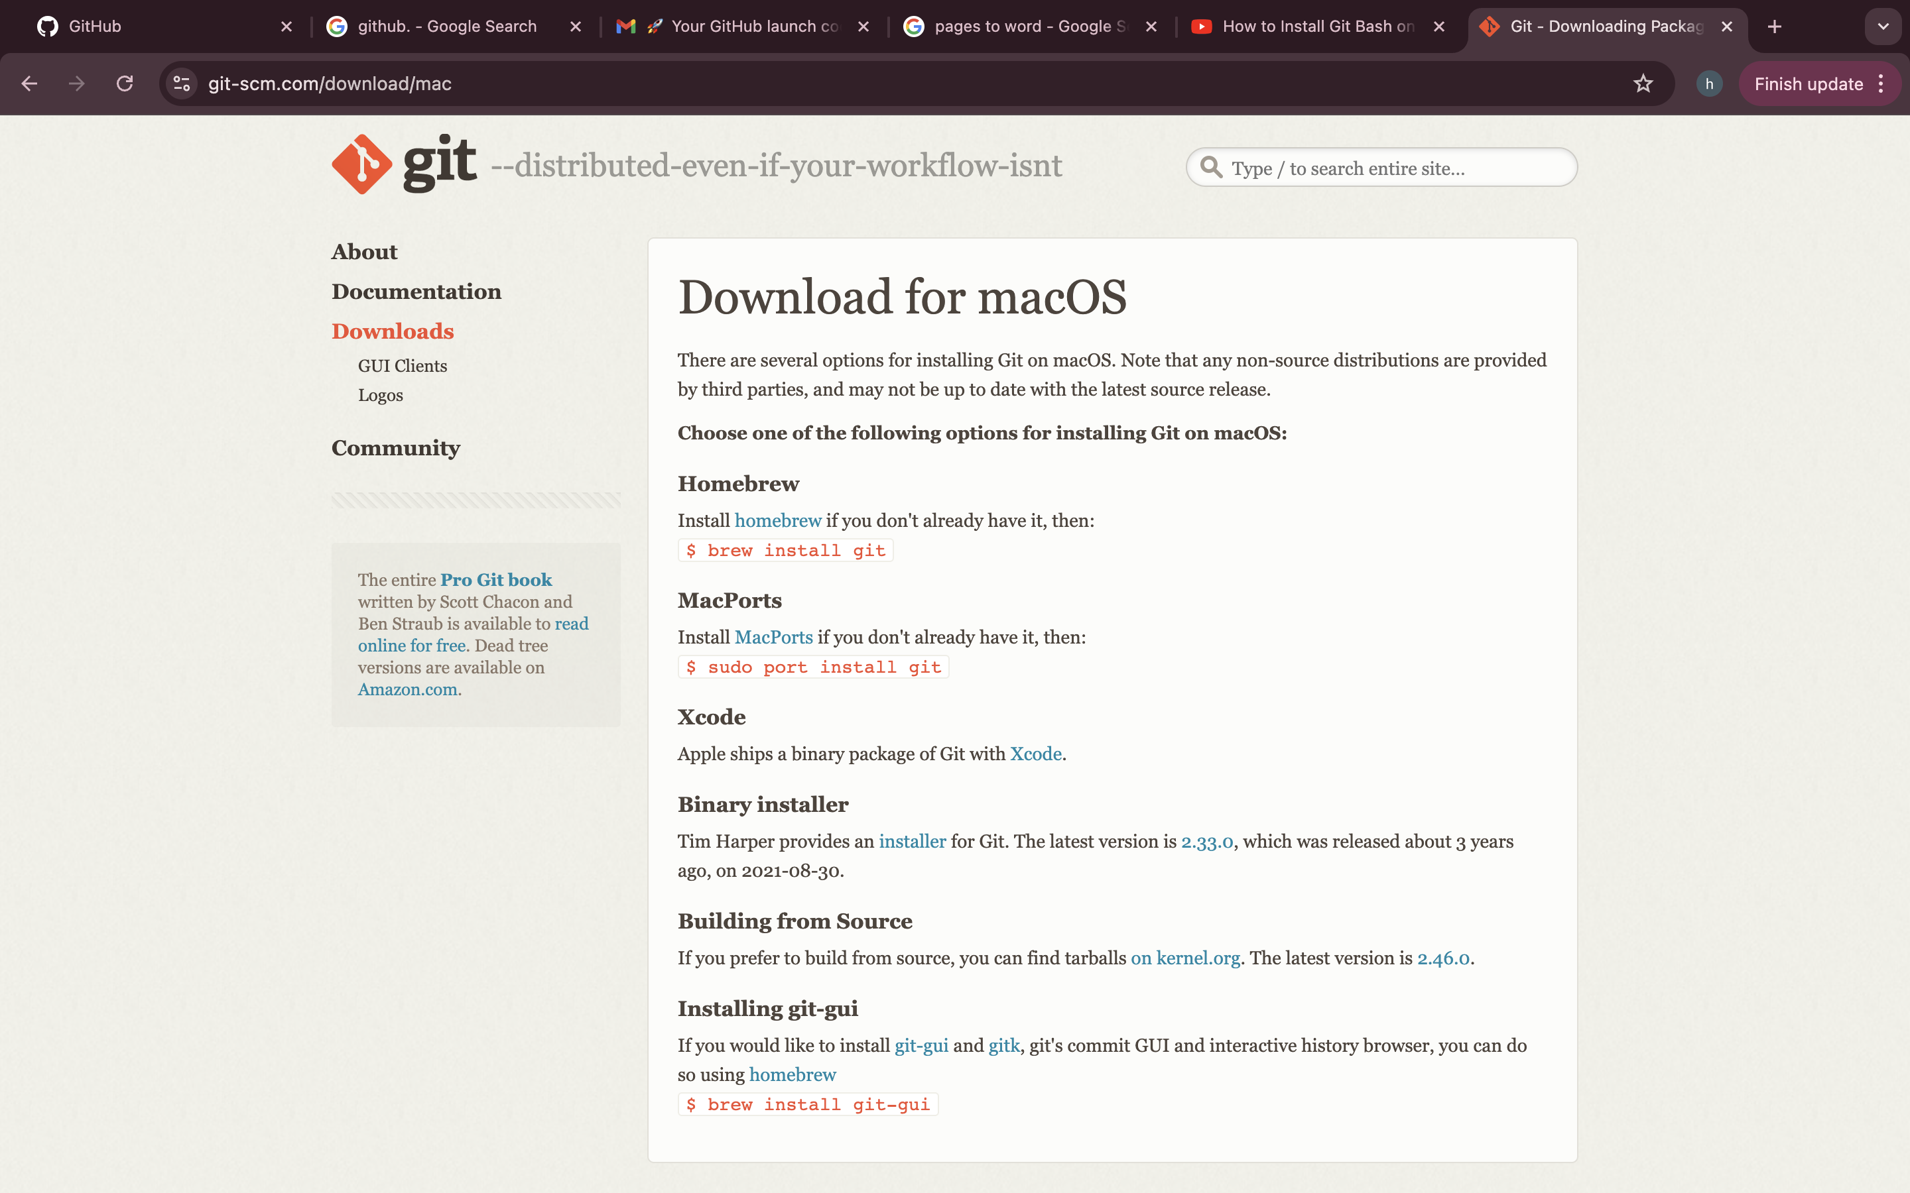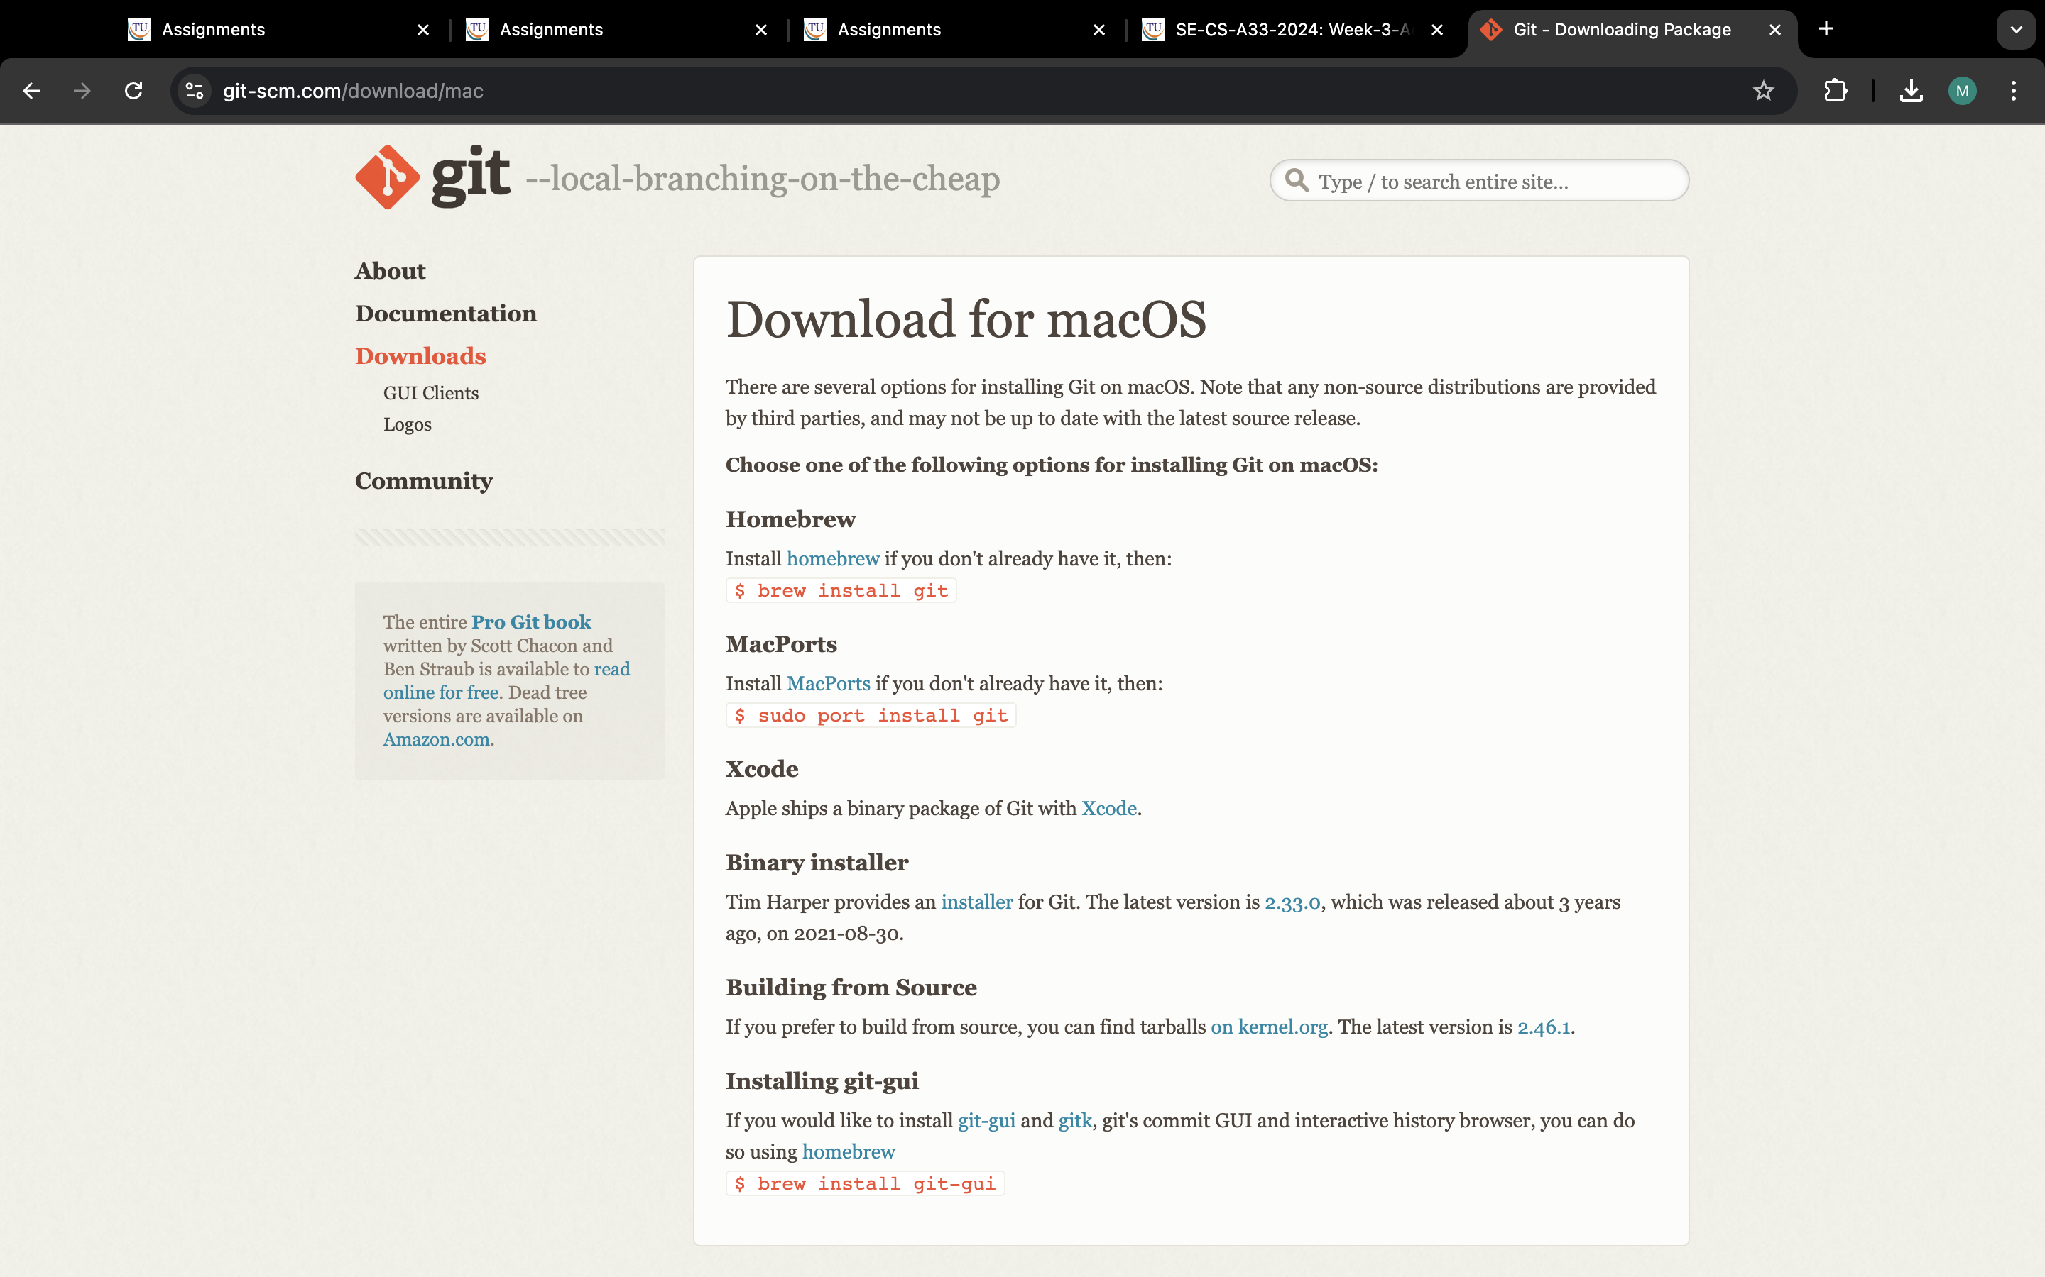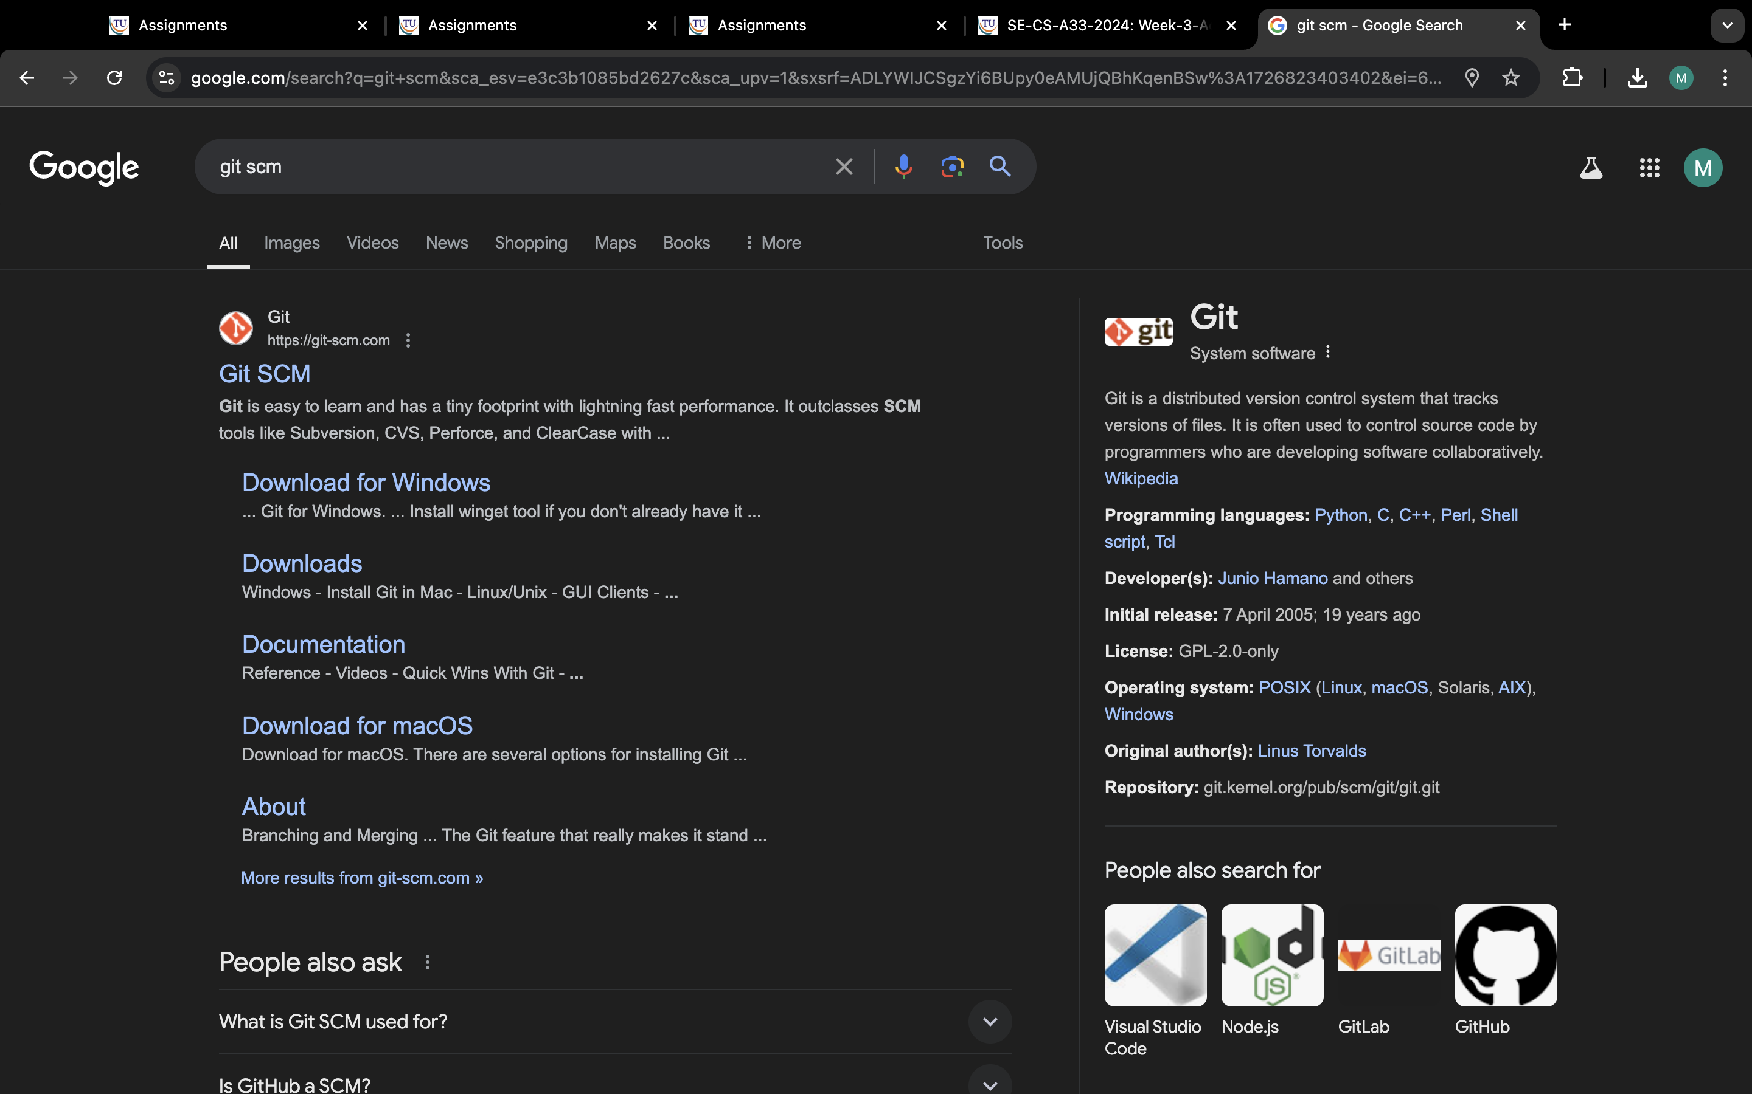

**Step:-2**

**Go to downloads option and select option according to your operating system**

**An**

**Step 3:**

**Go to terminal and enter command “brew install git”**

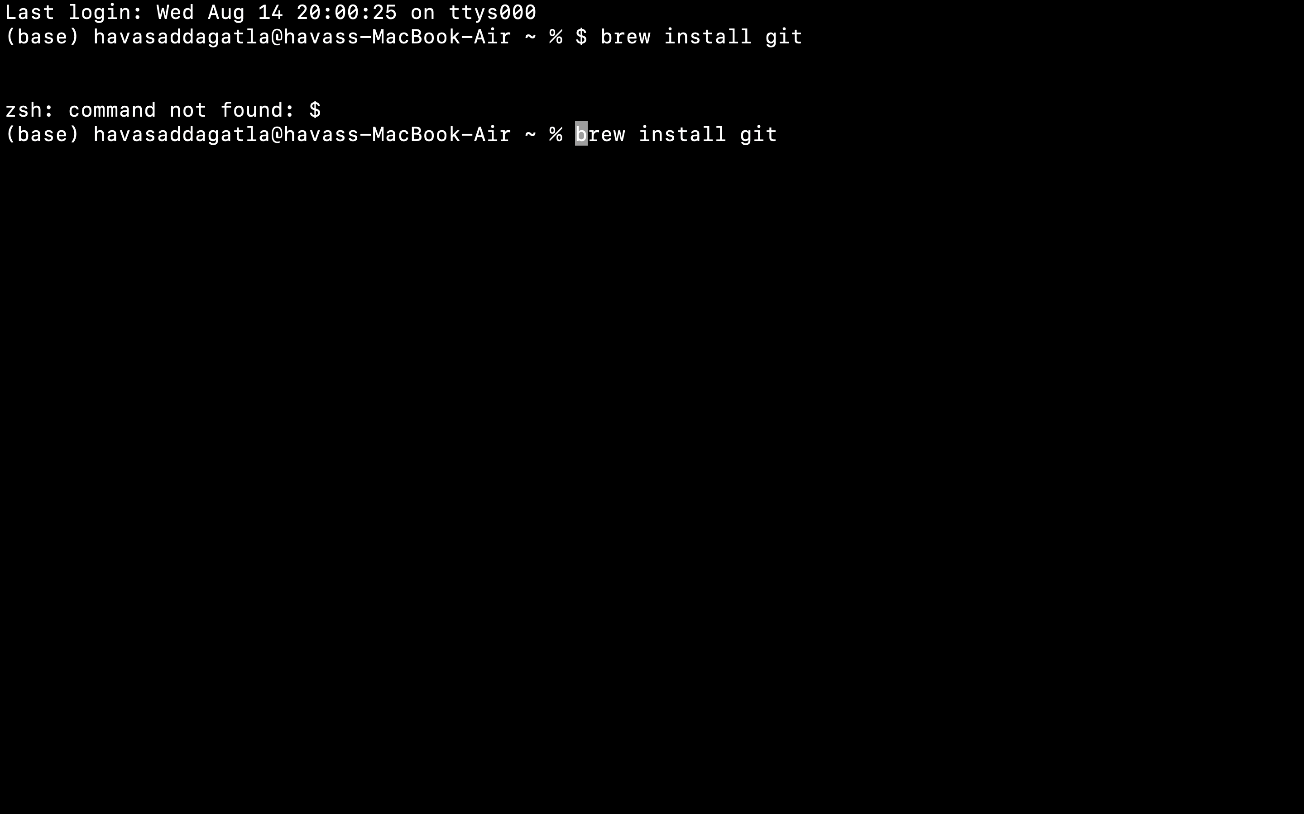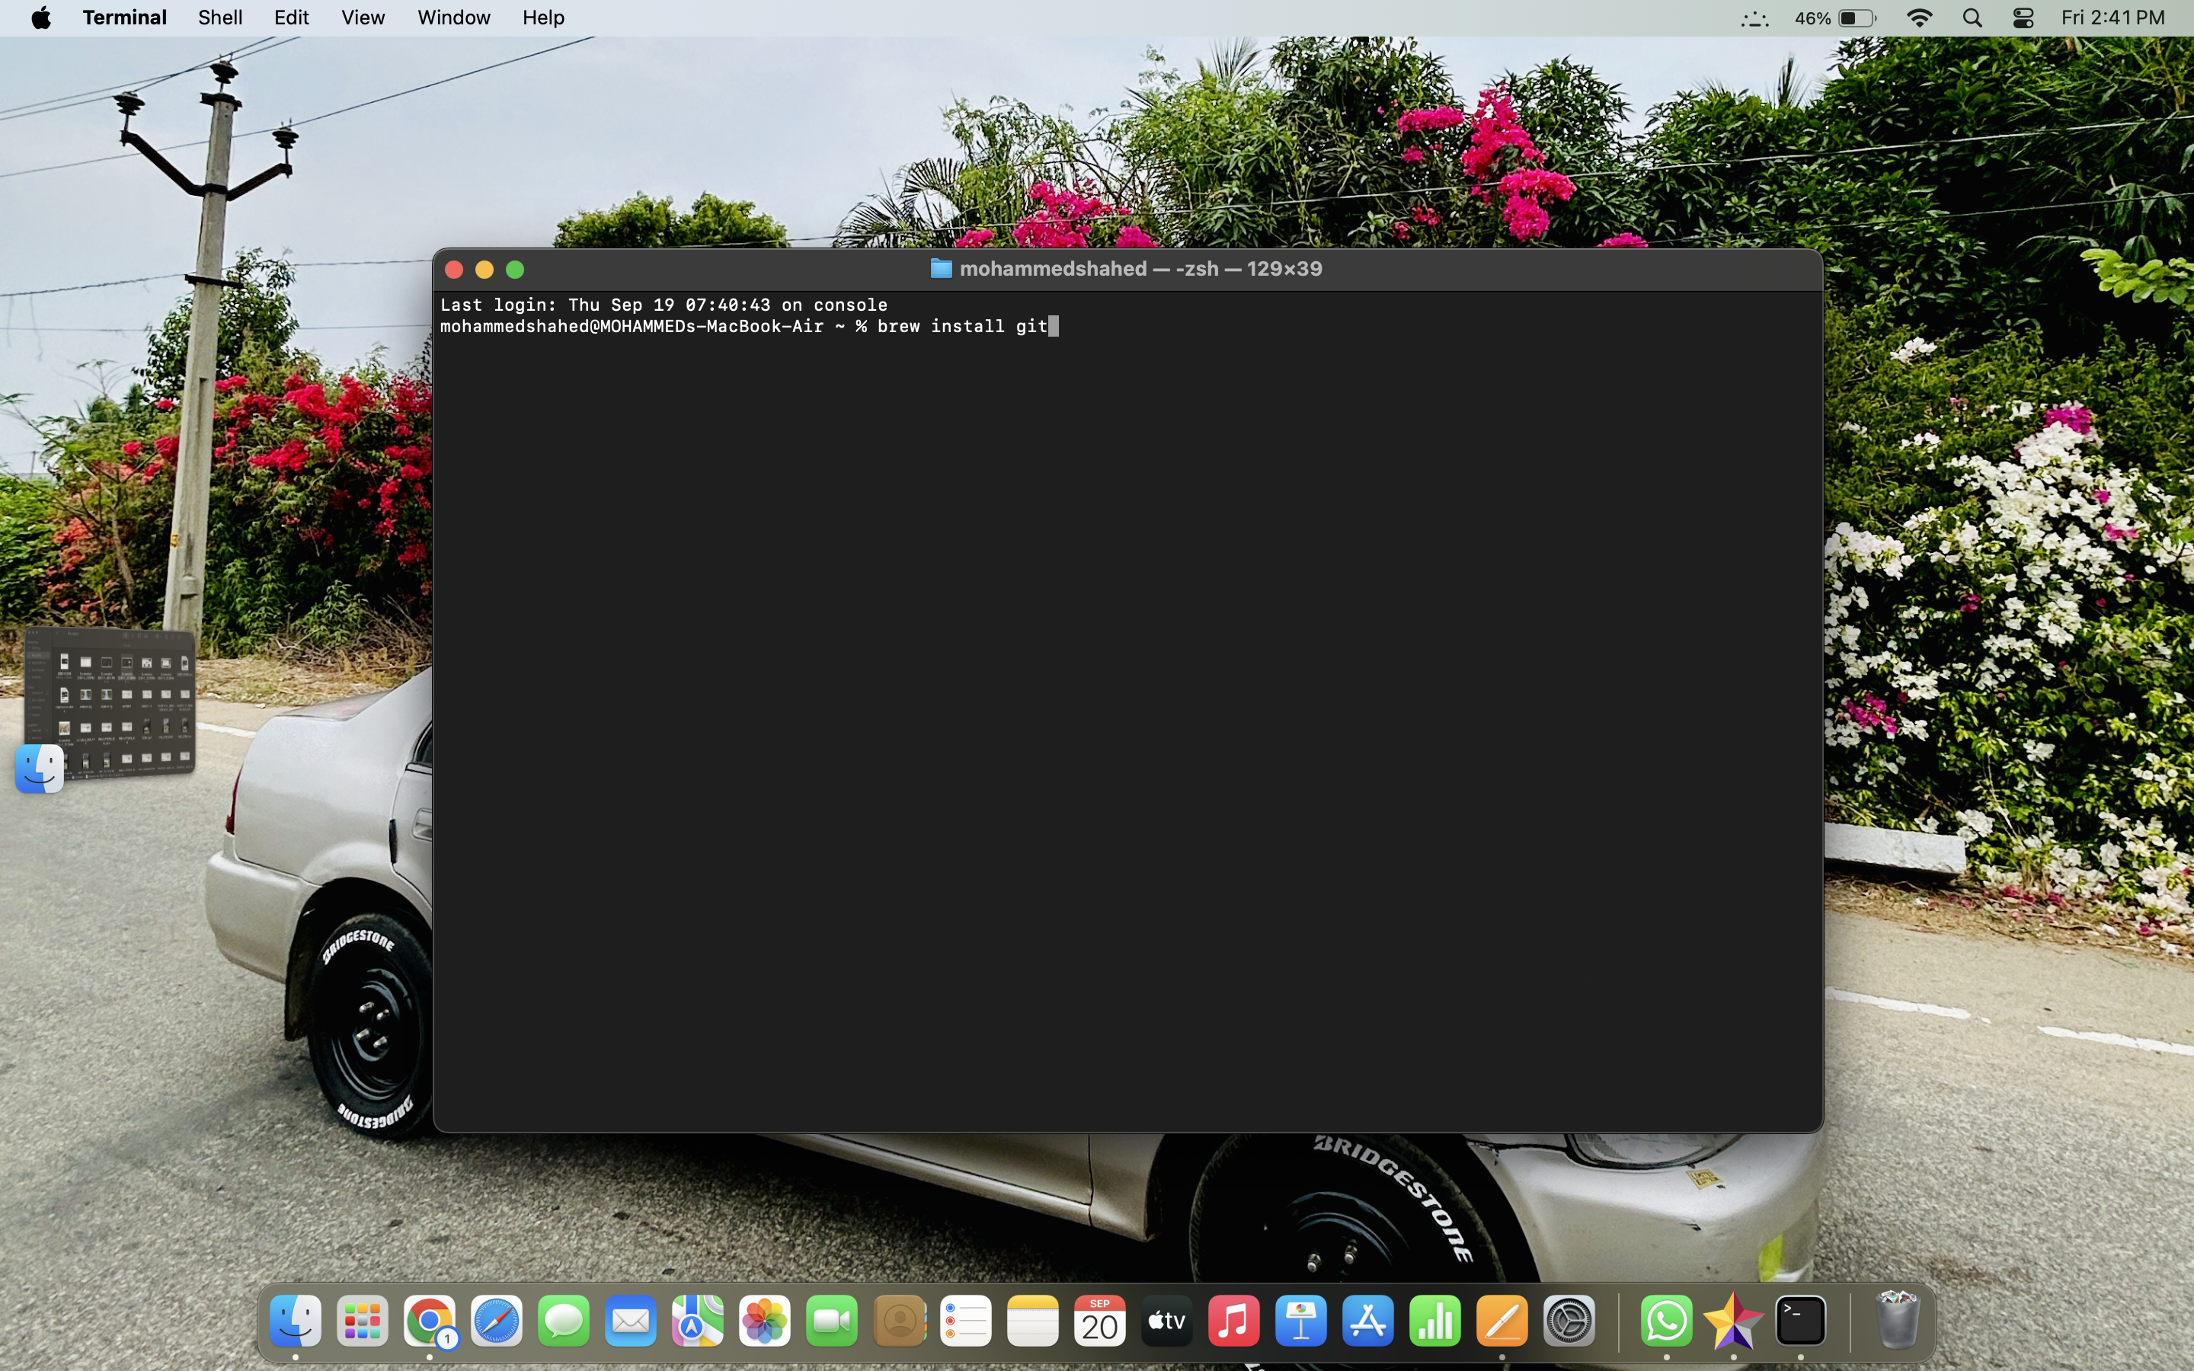

**Step 4: Now install the command “brew install git-gui”**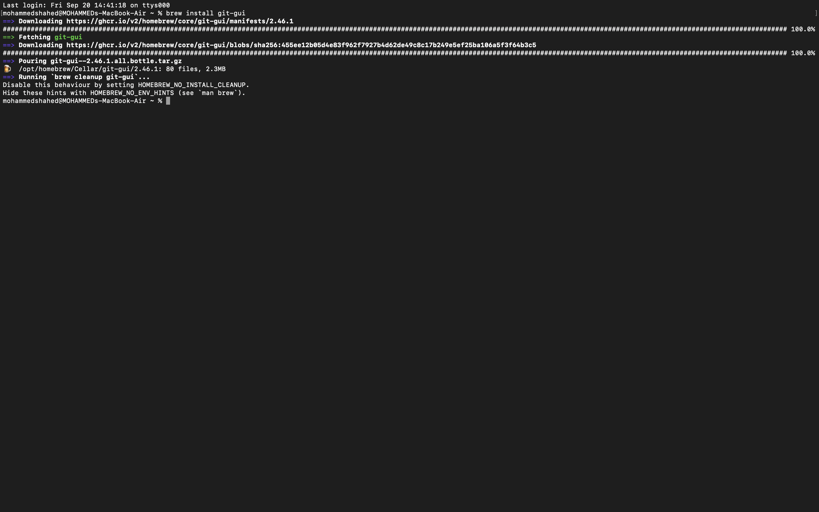

**Step 5: After installation check if is installed or not by entering the following command**

**“git —version”**

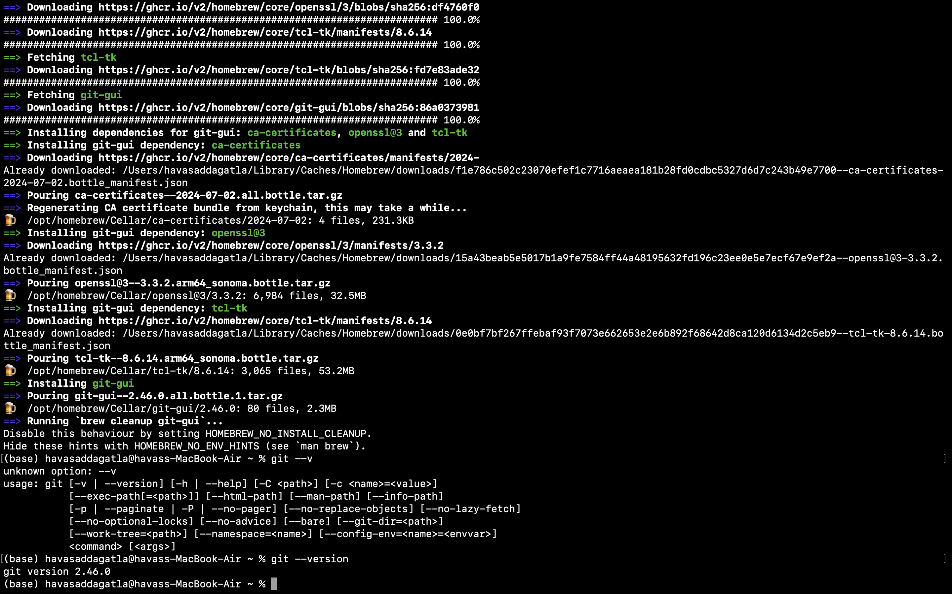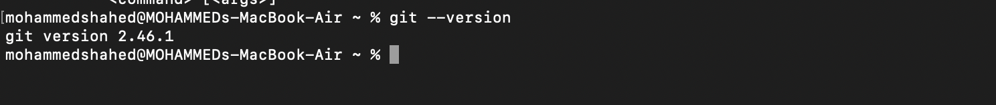

**Creation of Git-Hub account:**

**Step 1: Go to browser and search for** <https://github.com>**/**



**Step 2:click on sign up option**

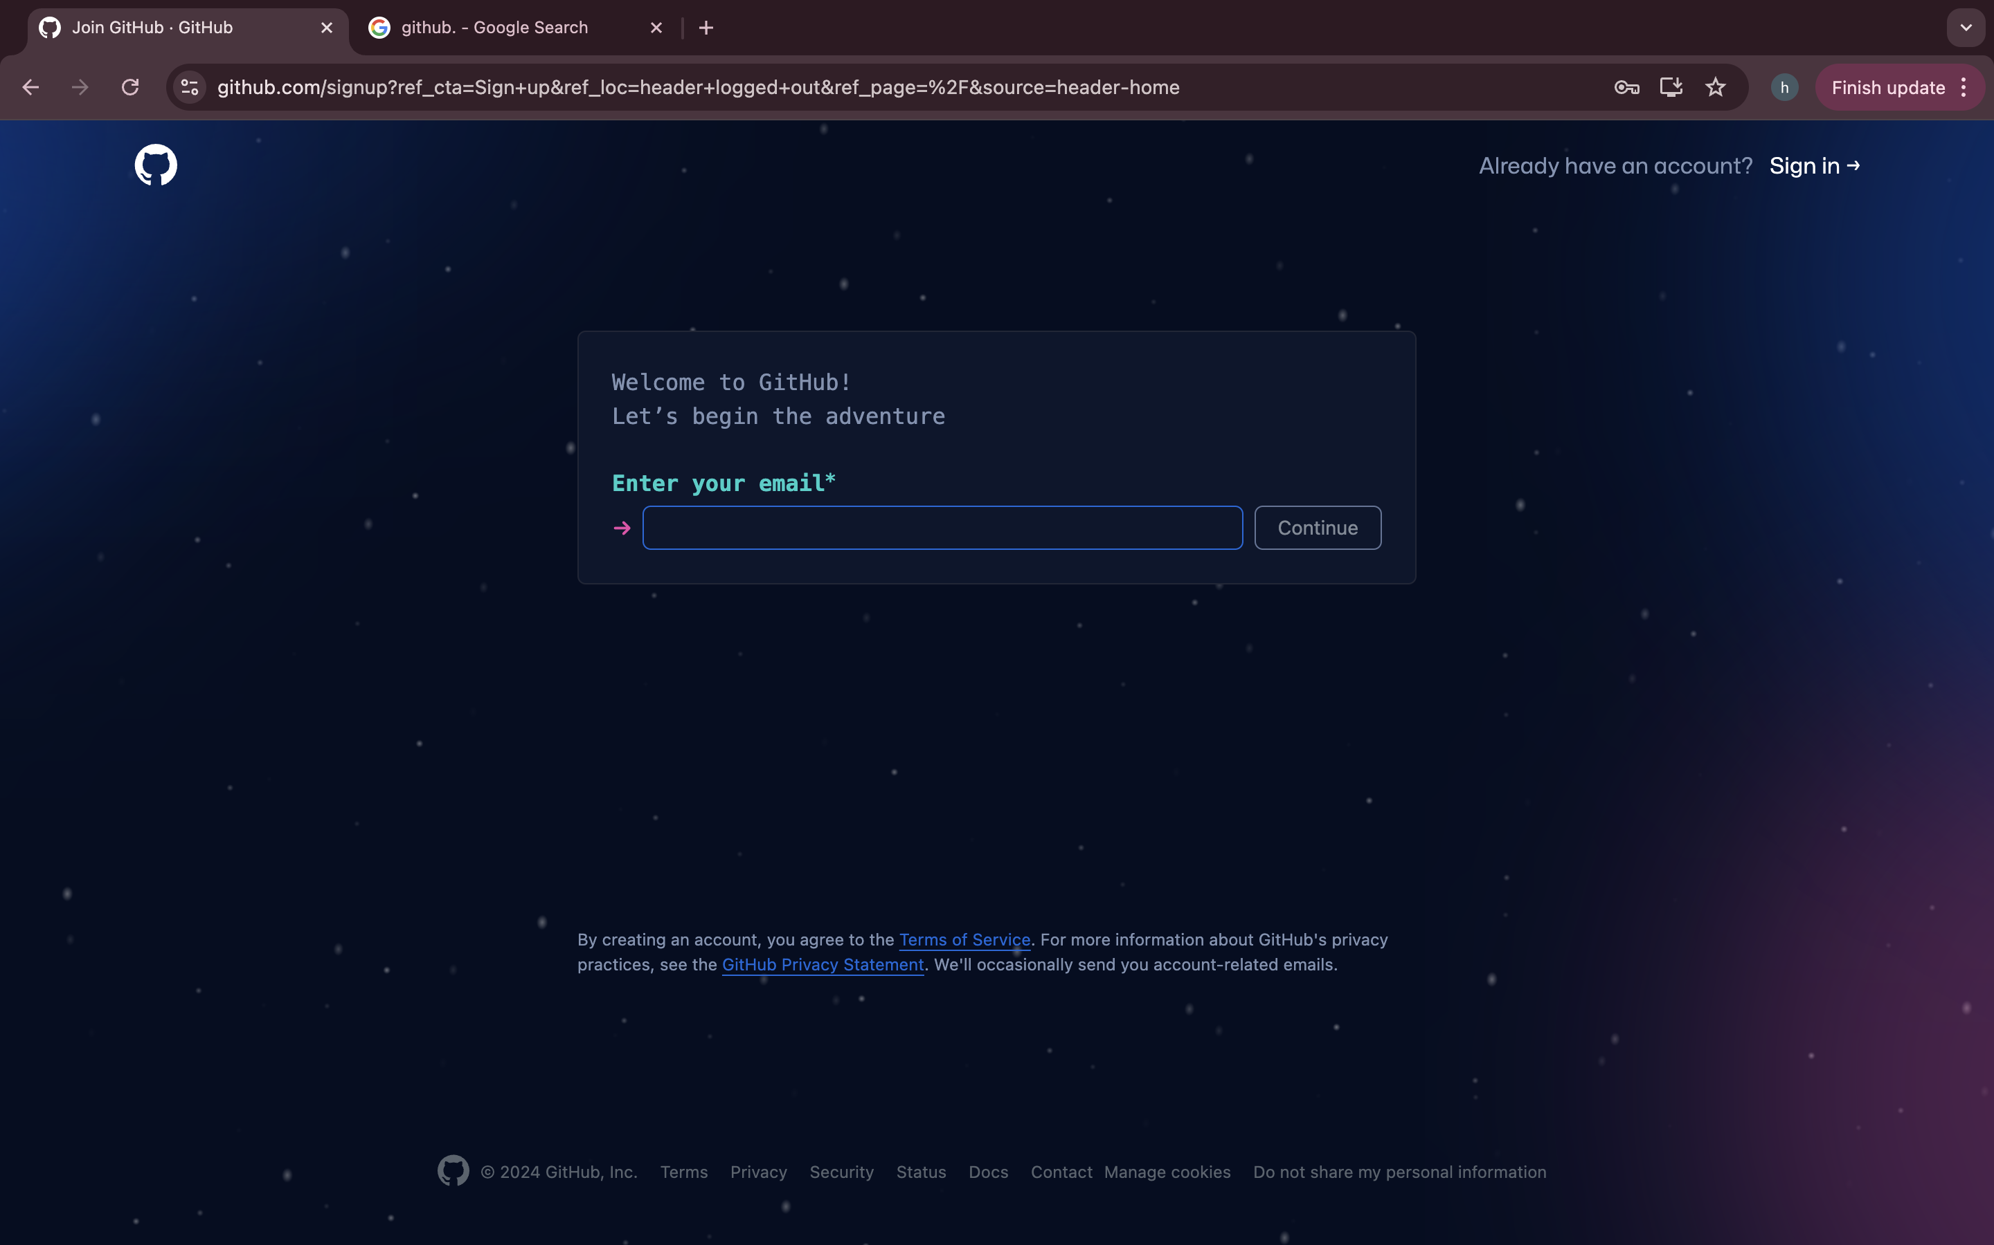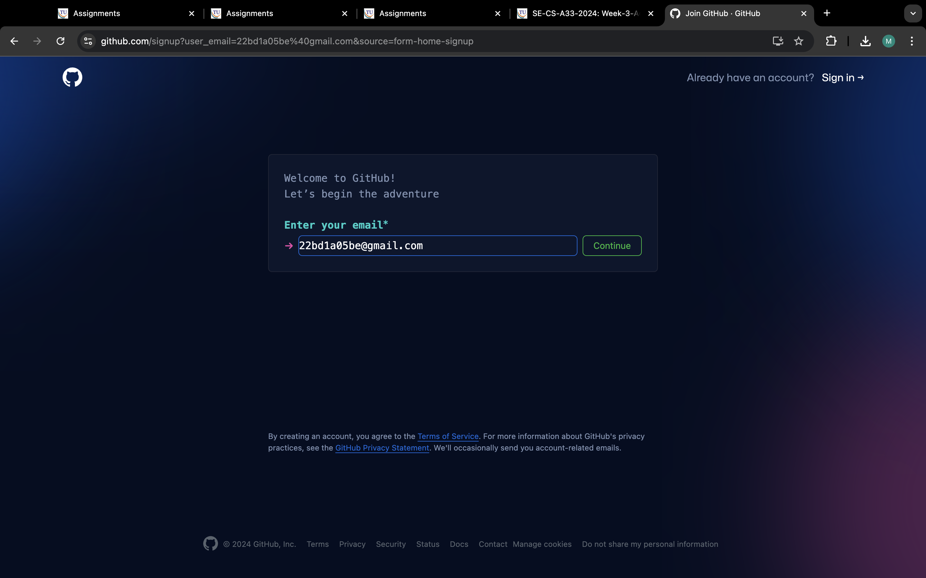

**Step 3: Enter your email address and create a password for it.**

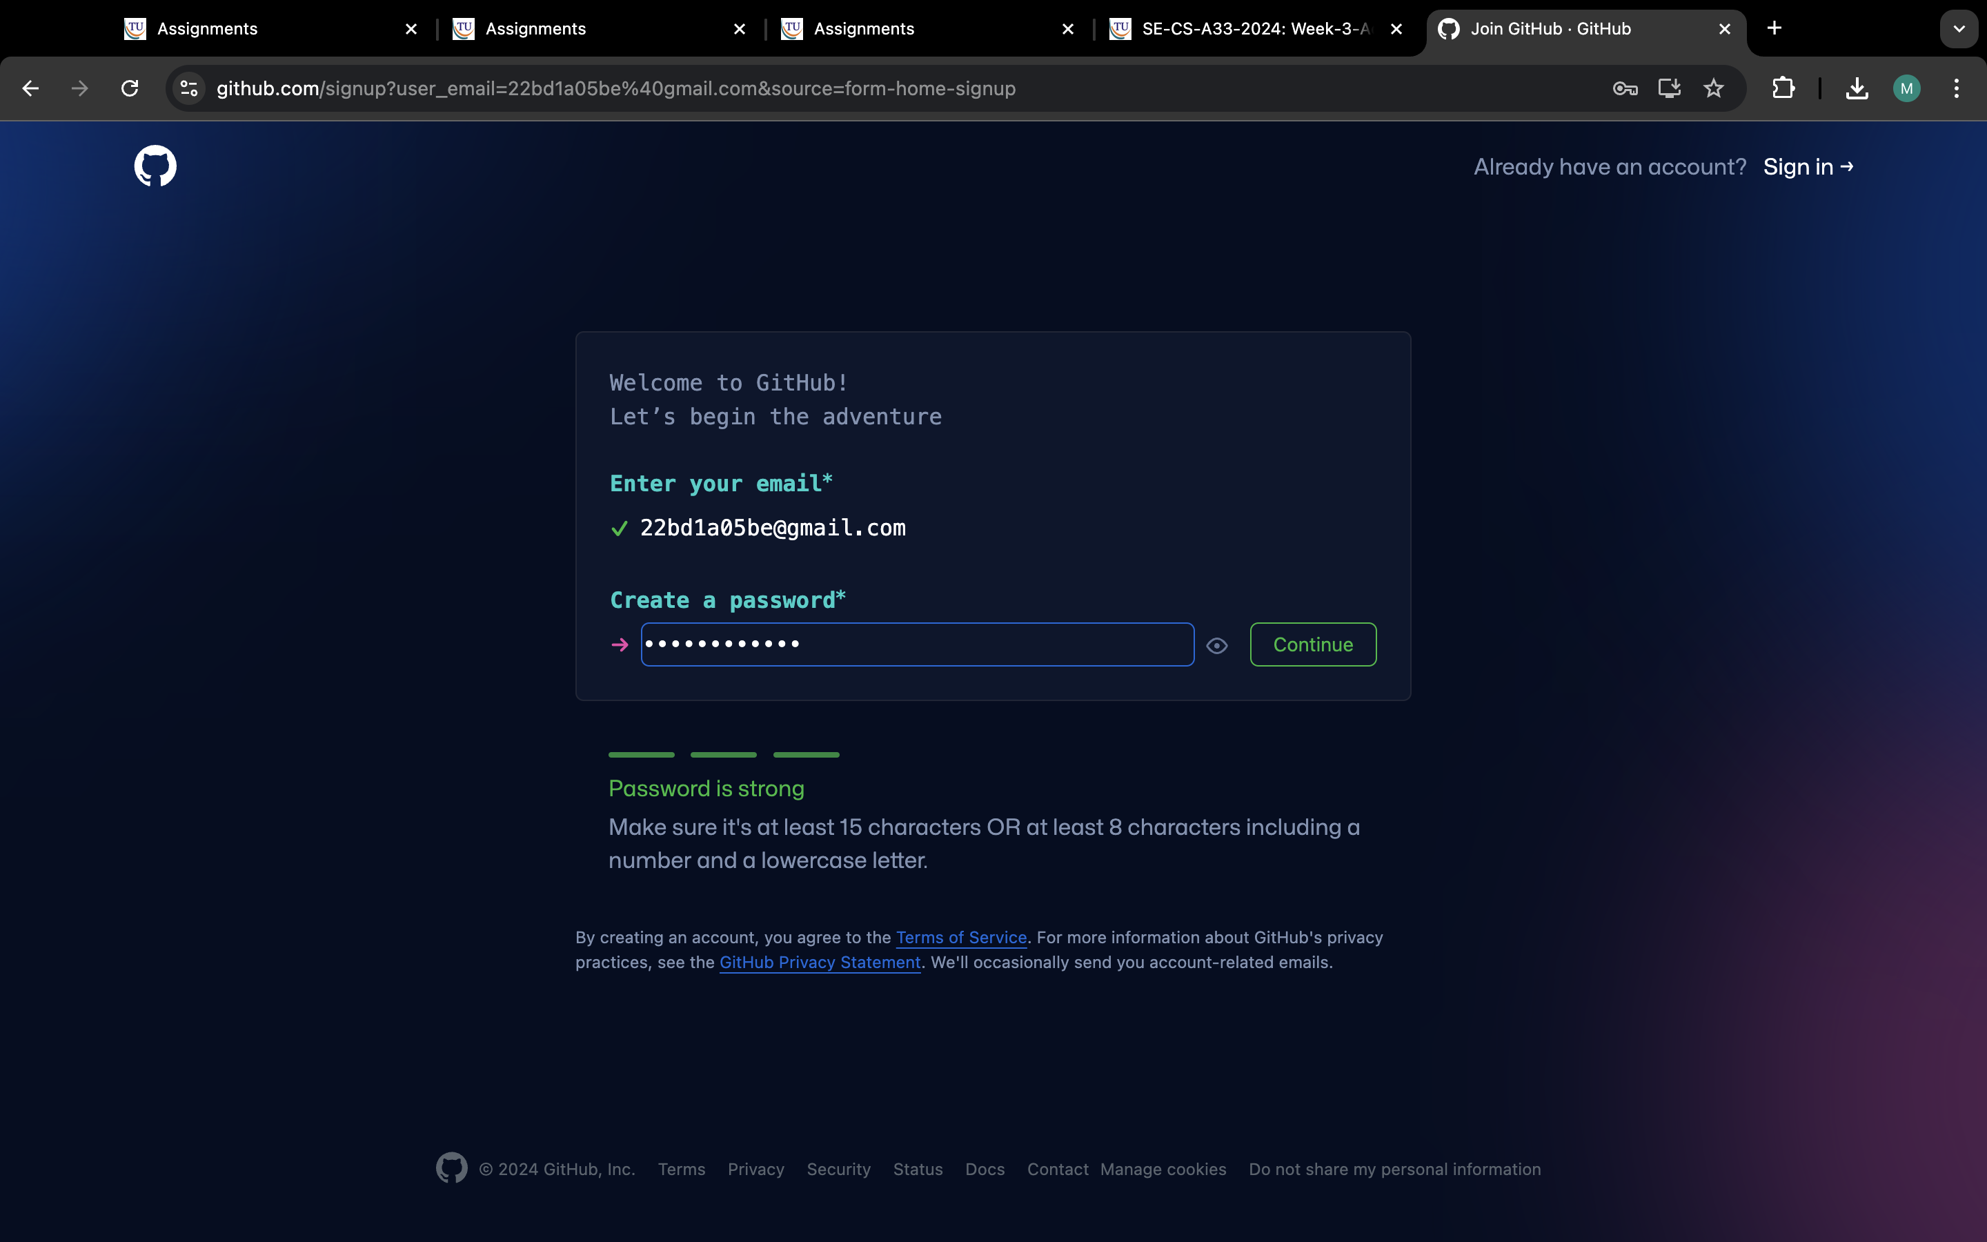

**Step 4: Enter the username and click on verify**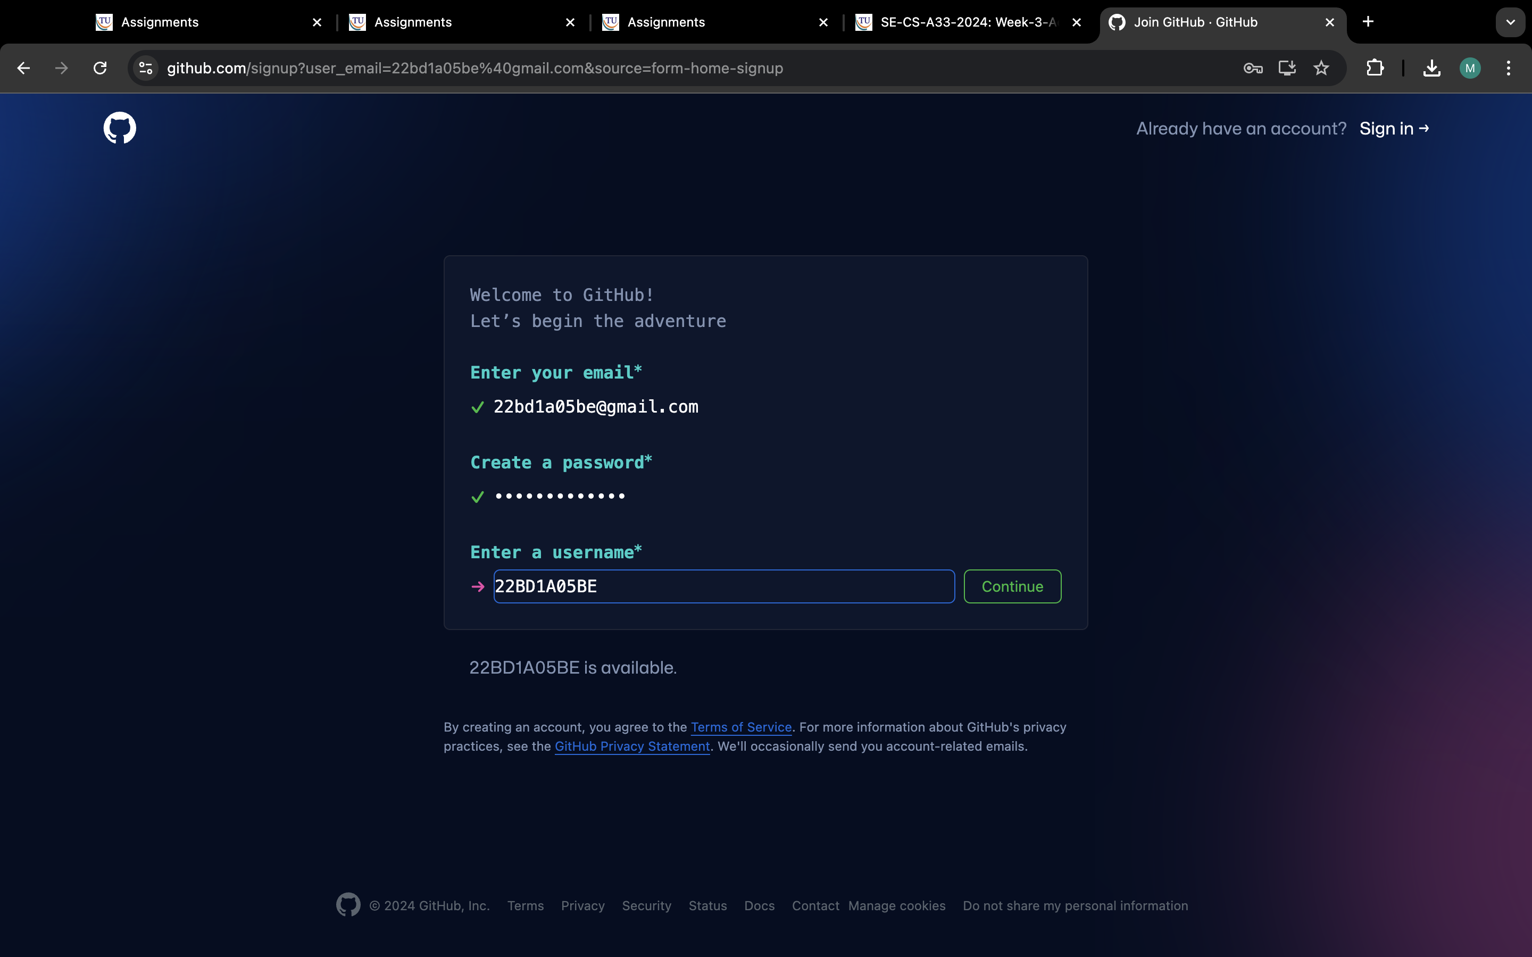

**Step 5: Successfully account has been created. Now sign in with your Email/Username**

**and password**

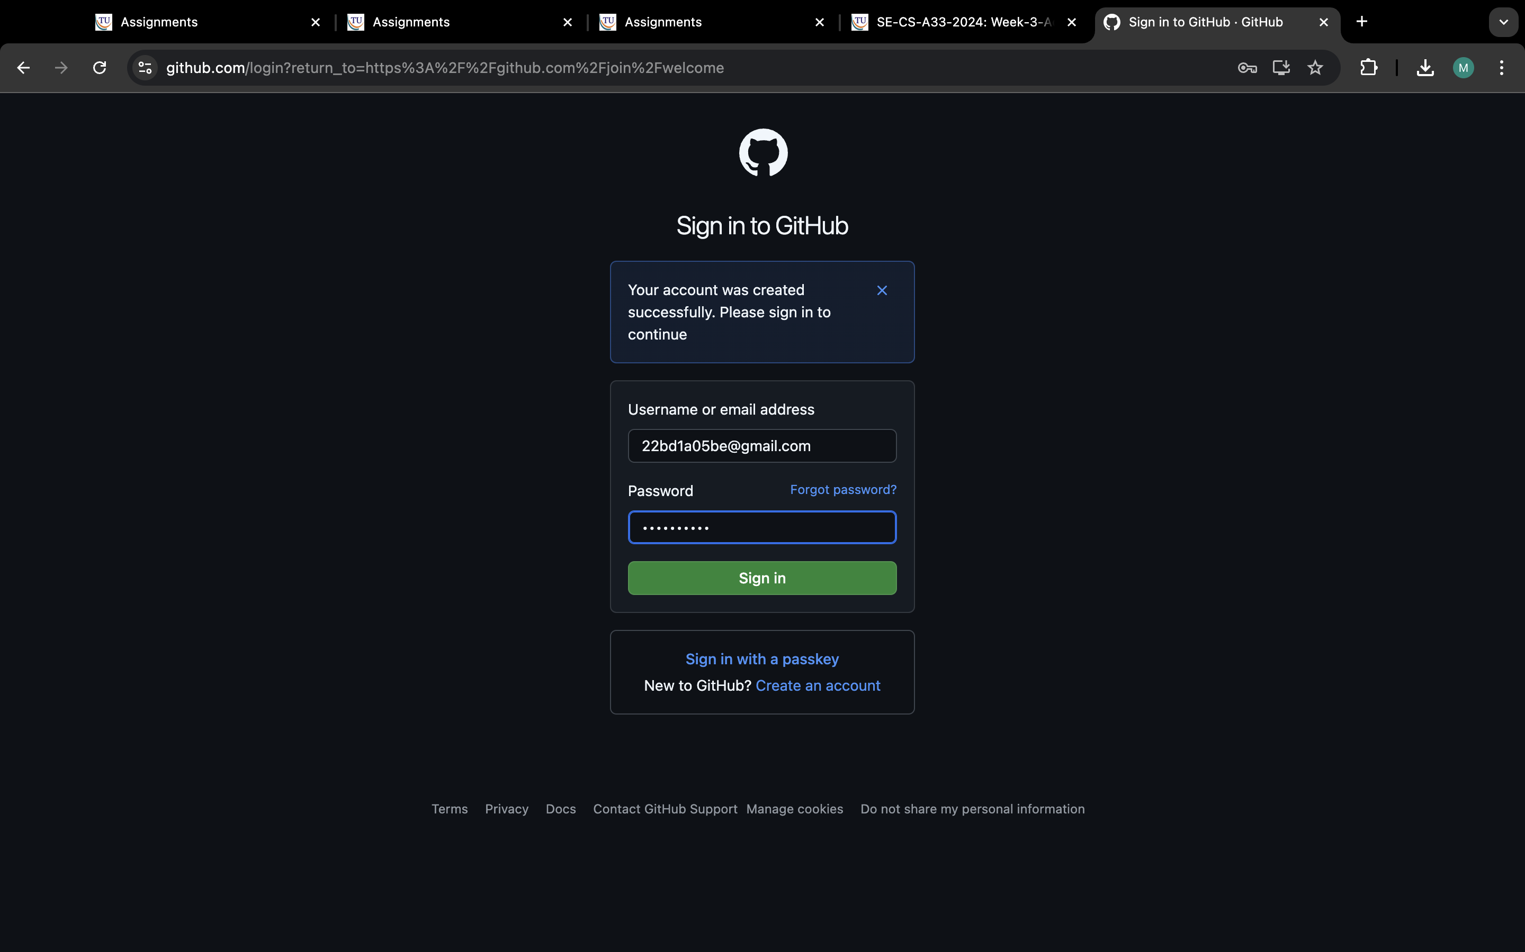

**Step 6: Successfully account has been created.**

